macrophages
then neutrophils
then P as external
then add feedbacks through contact or through global variable as secreted...BEFORE chemical field
count of neutrophils gives you net inflammatory signal
THEN spatialize so neutrophils secrete a chemical field
1. PUT model into antimony and plot
2. create neutrophil etc cell types without doing anything
3. have M1 and M2 divide and die and check reasonableness of results
4. have pathogen affect M1, M1 affect M2, just that part of network passed thru global variable
PURPOSE here is to check if it works
5. add neutrophil pair
6. now decide which should be same everywhere (blood versus tissue resident), global versus chemical field
7. local are fields
check 2020 and 2021 videos

Macrophage differentiation in homeostasis versus during inflammation
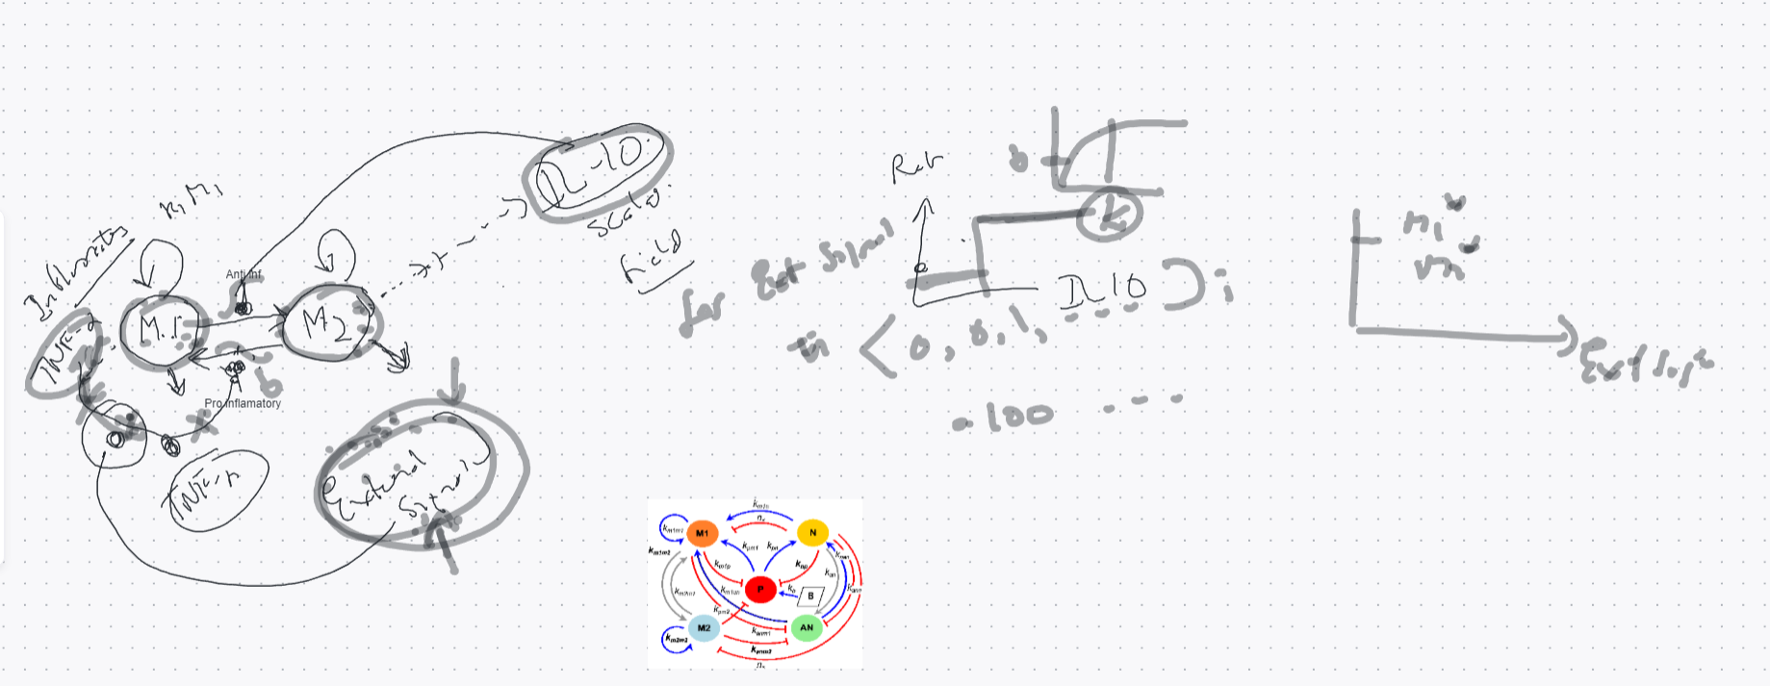

Objectives:
- Investigate macrophage pop. shift in response to LPS as a first step to more complex innate immune response model
Entities:
- M1 (pro-inflammatory) and M2 (anti-inflammatory) macrophages
- Pro-inflammatory cytokine (P)
- Anti-inflammatory cytokine (A)
- LPS
  - Modeled as a constant value field, but could be a gradient
  - Could change name to “Inflammatory stimulus” and comment in options like cyclical damage (wood smoke/PM exposure from cooking), pulse?, vector field?
- Anti-inflammatory
  - Can also begin as a constant value field, or gradient…if both anti-inflammatory and LPS are gradients, we can look at regions of high/low on one simulation

Biological processes (* next to processes not yet included):
- Mitosis
  - Inhibited by LPS [1]*
  - Probability of phenotype of daughter cell depends on local cytokine levels: > P -> higher prob daughter cell is M1, etc*
- Death
  - Natural death + LPS induced cytotoxicity [2]*
- Secretion:
  - M2 secrete baseline level of anti-inflammatory [3]
  - M1 secrete pro-inflammatory dependent on local LPS
    - secretor.secreteInsideCellAtBoundary(cell, 0.05*amount_seen_LPS**2/(2.5**2+amount_seen_LPS**2)), which works out to a constant 0.05 right now since LPS is constant
  - M2 secrete additional anti-inflammatory cytokine dependent on exogenous anti-inflammatory, say IL-4*
  - A should decay*
  - P should decay*
- Transition between phenotype:
  - If P seen by cell is above a threshold, M2 transitions to M1
  - If A seen by cell is above a threshold, M1 transitions to M2

Hypothesis/Validation:
- In absence of LPS (or other inflammatory stimulus), M2 should eventually dominate independent of initial condition ✅
- Without transition, if the ratio of Mitosis/Death ≈ 1, M1 and M2 should be about equal in a well-mixed scenario, but initial placement of cells may have large impact ✅
- Should see a switch as LPS is increased, since at homeostasis most or all are M2. We discussed generating a bifurcation graph

Environment and cell properties - in parameters file.

Macrophage width [5]

Why do we need spatial dynamics?
- Migration from bloodstream to site of inflammation and buildup of cells at site is an important driver of inflammatory process in many diseases like COPD, atherosclerosis, etc
- Epithelial cells line airways and blood vessels and damage to the cells causes chemokine release and expression of adhesion molecules
- These signals recruit cells
- Adhesion is what allows the immune cells (neutrophils first) to enter the tissue from the bloodstream and migrate to the inflamed or infected site (extravasation)
- Interactions between the immune cells and epithelium can create positive feedback, BUT
- Neutrophils respond first, and it’s the clearance of the apoptotic neutrophils at the site that drives the M1 switch to M2 and resolves inflammation and return to homeostasis
- So chemokine/cytokine gradients are important, they drive the extravasation from blood vessels, cell migration to site, and apoptosis are key spatial considerations. Not just in lung inflammation, but any local inflammatory process
Questions
- Role of epithelial cells:
  - Explore the influence of epithelial cells in the lung on macrophage differentiation in response to inhaled particulate matter like wood smoke.
  - Investigate how epithelial-macrophage interactions contribute to the overall immune response and whether these interactions modulate M1/M2 polarization.
- Impact of environmental factors/external stimulus:
  - Model the impact of different concentrations and types of inhaled particulate matter on macrophage differentiation.
  - Explore how variations in the exposure to wood smoke influence the immune response and macrophage polarization.
- Feedback mechanisms:
  - Investigate feedback loops that regulate macrophage polarization and how these mechanisms contribute to the resolution or perpetuation of inflammation.
  - Examine the role of negative regulators in controlling macrophage activation and polarization.
- Integration of multiple signals:
  - Investigate feedback loops that regulate macrophage polarization and how these mechanisms contribute to the resolution or perpetuation of inflammation.
  - Examine the role of negative regulators in controlling macrophage activation and polarization.
- What data?

[1] Liu, L., Lu, Y., Martinez, J., Bi, Y., Lian, G., Wang, T., ... & Wang, R. (2016). Proinflammatory signal suppresses proliferation and shifts macrophage metabolism from Myc-dependent to HIF1 α-dependent. Proceedings of the National Academy of Sciences, 113(6), 1564-1569.
[2] Xaus, J., Comalada, M., Valledor, A. F., Lloberas, J., López-Soriano, F., Argilés, J. M., ... & Celada, A. (2000). LPS induces apoptosis in macrophages mostly through the autocrine production of TNF-α. Blood, The Journal of the American Society of Hematology, 95(12), 3823-3831.

[3] Reynolds A, Rubin J, Clermont G, Day J, Vodovotz Y, Ermentrout GB. A reduced mathematical model of the acute inflammatory response: I. Derivation of model and analysis of anti-inflammation. Journal of theoretical biology. 2006;242(1):220–236. pmid:16584750

[4] Krombach, F., Münzing, S., Allmeling, A. M., Gerlach, J. T., Behr, J., & Dörger, M. (1997). Cell size of alveolar macrophages: an interspecies comparison. Environmental health perspectives, 105(suppl 5), 1261-1263.

